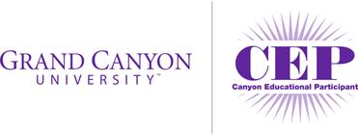

We are pleased to be a new participant in Grand Canyon University’s **Canyon Educational** **Participant program (CEP)**. This program provides members of our community with a variety of benefits, such as:

* A 10% scholarship for CEP staff, members, and governing board members
* A 15% scholarship for paraprofessionals or classified staff entering an online bachelor’s program through the College of Education, a Secondary Education Emphasis degree program, or the Bachelor of Science in Applied Management degree program
* A 5% scholarship for spouses of staff, members, and governing board members
* Professional Development and Speaker opportunities
* Access to the GCU Online Job Board
* Discounts on GCU academic and athletic camps, and events sponsored by K12 Educational Development
* Opportunities to utilize GCU resources to support our programs

If you are interested in learning more about online degree programs, please contact GCU’s University Development Manager, Haylee Bunnell, [Haylee.Bunnell@gcu.edu](mailto:Haylee.Bunnell@gcu.edu).

If you would like to learn more about GCU’s traditional campus, you can reach the local University Admissions Counselor at 1-855-GCU-LOPE. If you are interested in learning more about GCU’s doctoral programs, email [doctoral@gcu.edu](mailto:doctoral@gcu.edu).

Please note that if you are a current GCU student, the scholarship will apply to all your future classes as long as you are continuously enrolled in the program. The 15% scholarship for paraprofessionals and classified staff is available to new students only.

To learn more about GCU, please visit gcu.edu.

Thank you,